The CLS system places patterns along a common shear line for quick, clean, accurate shear separation
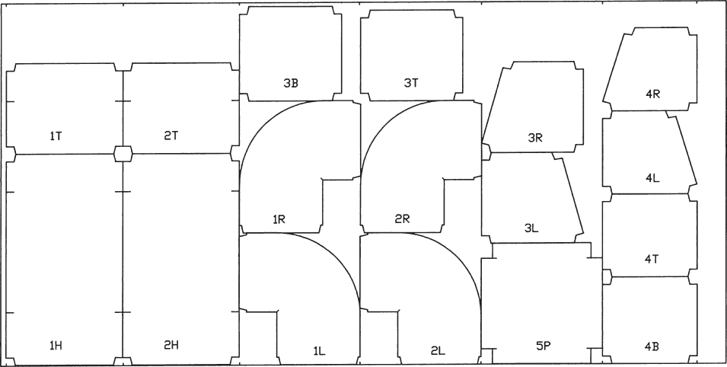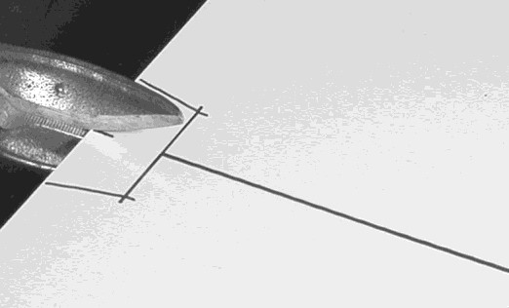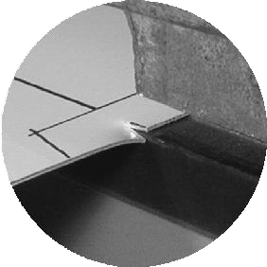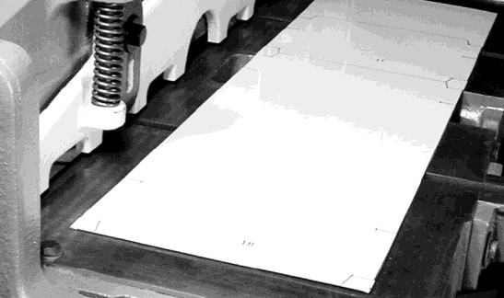
Tick marks are
automatically
placed
to locate primary shear cuts.

Simply
nick
at the tick mark.

Then
pull
until the nicks
catch on the
lower jaw of
the

shear.

You
get
accurate
primary
shear cuts
every time
. There
is no need for sighting or
dependence on mis
-
aligned
shear guides. Shear
-
cut
edges produce
less wear
on
edge forming equipment
than plasma
-
cut

edges.

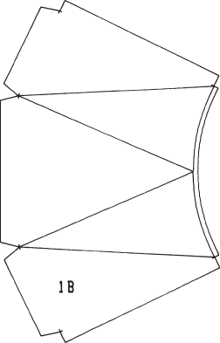
The CLS pattern layout system places guide marks for edges, seams, bends, folds and rolls. Fitting numbers and letters corresponding to the part within the fitting are also drawn on the metal. The patterns are drawn with a Sharpie® Extra Fine Point Marker, which is the only consumable system item. Sharpie® pens are inexpensive and readily available. Since the patterns are arranged in columns, they are easy to separate. Sheet lay- outs can be viewed on-screen to estimate metal usage. Up to 99 fittings can be entered into the NICAL software at once. Jobs can be saved and run anytime. Here are some of the many fittings possible on a CLS system.
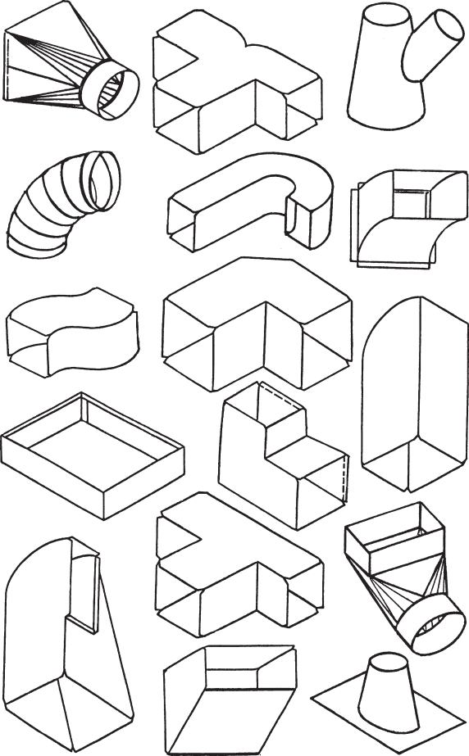
Includes:
Layout Table
NICAL Software
Computer, Monitor & Stand
Cables
Pens (24 Sharpie® pens)
Warranty:
2 Year Warranty
Power Requirements: 120VAC, 6A
The CLS-408 system can be transported in a standard 8 ft. truck bed.
NICAL Software Features: The CLS system produces more than a dozen seams and a dozen edges that can be modified according to the needs of your shop. The CLS system can layout up to 99 fittings at one time.
NITEC

NiTec, Inc., P.O. Box 1097, Hagerstown, MD 21741 Call: 301-791-7729 or Fax: 301-791-9297

